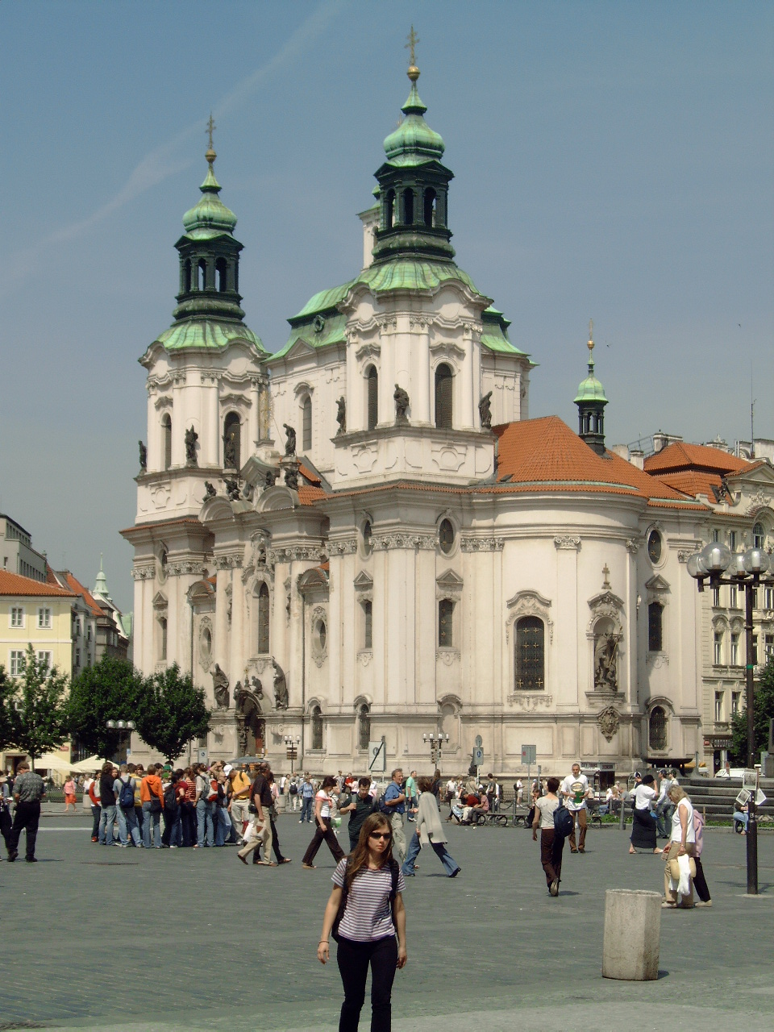


Vienna

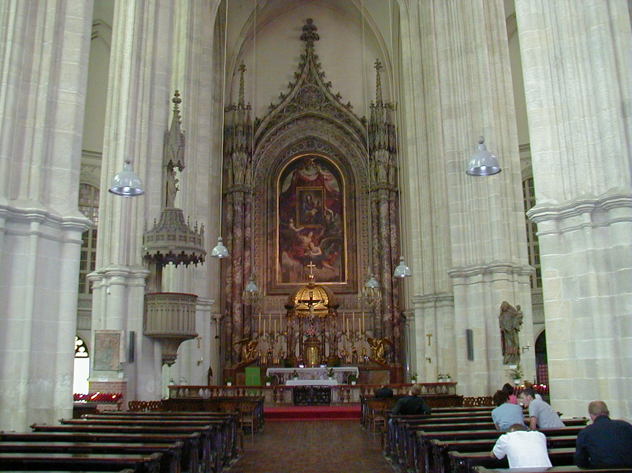
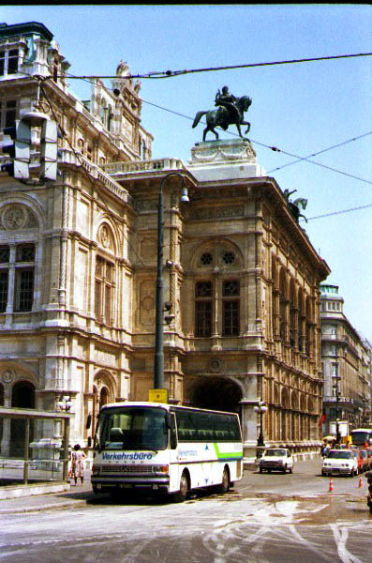
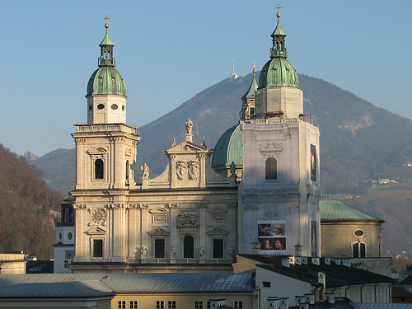

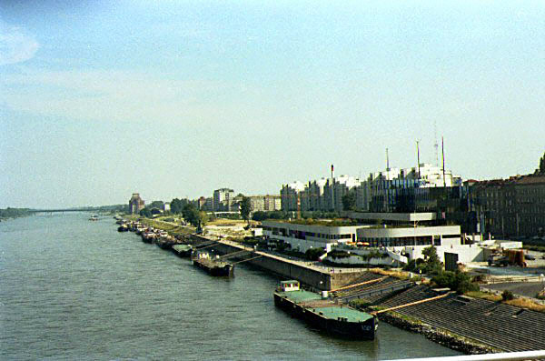

Program Itinerary

Vienna

Day 1 Flight
Board your overnight flight to Vienna today. Meals served on board.

Day 2 Vienna
Arrival in Vienna, the capital of Austria, with its 17th-century houses and quaint baroque squares tucked in all corners of the city. Every district boasts of houses where Beethoven, Mozart, Mahler or one of the Strauss’s lived. Enjoy a guided tour to see the main sights of Vienna; you will see Opera building and the Symphony Hall, the Ringstrasse, Hofburg and a visit of the Stephans Dom. Possible visit to the Central Cemetery where you can see graves of famous composers like Beethoven, Brahms and Mozart.
Dinner and overnight in Vienna.

Day 3 Vienna
This afternoon visit the Schönbrunn Palace, the fabulous baroque summer residence of the Hapsburg Emperors. Here Marie-Antoinette lived as a young girl. The rococo interior is re-created as it was at its zenith. Here the six year old Mozart played for the empress inside the Palace. Also, stroll through the beautiful gardens filled with flowers and statues.
Possible (informal) performance in front of the grand stairs of the Palace. In the afternoon you have some leisure time. You can for example visit Hotel Sacher where you can enjoy and taste the famous Sacher torte.
Dinner at local restaurant. Overnight in Vienna.

Day 4 Vienna
In the morning you can enjoy a visit of the House of Music a modern interactive museum dedicated to sound and music situated in an historic palace. A journey through the magic world of music… Let your ears take a stroll…
Visit the Vienna Philharmonic Museum on the first floor, as well as the room of giant instruments, the sound gallery and much more!
In the afternoon possible performance in for example the Peterskirche or Votiv Kirche.
Dinner and overnight in Vienna.

Day 5 Vienna
In the morning we go to the Vienna State Opera House for a guided visit. You will see the foyer, main staircase, the Tearoom, Marble Hall and much more.
Have the afternoon at leisure for individual sightseeing or last minute souvenir shopping. Dinner and overnight in Vienna.

Day 6 Departure
Following breakfast this morning check out of your hotel, load your luggage on the coach and depart for the airport for your flight home.

Inclusions:
- 4 nights accommodation in tourist class hotels based on triple bedded rooms with private facilities
- Continental breakfast daily
- Daily 3-course dinner, excluding drinks
- European tour escort throughout
- Private luxury coach for all transfers according to the itinerary
- Local guide; Vienna city tour
- Visits: Stephans Dom / Schönbrunn Palace / House of Music / Possible Central Cemetery (free of costs) State Opera
- Organization & promotion of 2 performance

Supplements:
Twin supplement: Euro 35 p.p. based on 3 nights
Single supplement: Euro 95 p.p. based on 3 nights

End of arrangements

Note: unexpected circumstances may cause changes to the order of events outlined in the itinerary.

Program Details

Included in your Travel Program

Transportation
- Round-Trip Air Transportation via regularly scheduled commercial air service – economy Class (in addition to land package)
- Chartered Motorcoach Transportation in Luxury air-conditioned coaches
Accommodations
- Hotel accommodation in 3 and 4 Star properties based on triple bedded rooms.
- In room bathroom facilities
- Directors free room can be a single room if requested
Meals
- Meals are as indicated on your itinerary.
- Breakfasts are continental style and in the hotels unless noted
Activities & Details
- All scheduled sightseeing and entrance fees per itinerary.
- Concert organization and promotion as listed on the itinerary
- Instrument rental is separate and not included
- Instrument transportation costs if any are not included
- Professional Tour Manager throughout
- Restaurant & Hotel Gratuities included
- Coach and Driver Gratuities are not included
  - Suggested tipping at $3 per person per day ($2 pp/pd for tour manager and $1 pp/pd for driver)
- Individual Participant insurance is an extra cost - $119 will be added to your invoice for each participant
- In the event that the venues listed herein cannot confirm the group for the intended travel dates, Travel Quest International (TQI) reserves the right to substitute venues of a similar standard and adjust our final daily itinerary accordingly. Performance venues often require music repertoire and/or music assessment. It’s always a good idea to get started early by sending us a CD or DVD and a copy of expected repertoire. We’ll quickly send copies overseas to get the venues excited and interested in having you come to perform.
- Please note that we specialize in customized group travel and can revise this program and further tailor it to meet the group’s needs and desires.
- The group will have a private motor coach and driver at their disposal throughout the tour for approximately 8-10 hours daily.
- We have only included guided tours as per the itinerary. In the other cities that do not include guided tours, there may or may not be time to visit on your own time. If there is time, the group will be briefed about the region by their tour escort. Please note that tour escorts are not licensed guides and are not permitted by law to give any sort of sightseeing tours. If you would like a guide for any of these locations, we would be happy to advise the additional costs and make the appropriate arrangements.
- Music stands, risers, keyboards, chairs etc may require an additional charge if requested.
- TQI reserves the right to make alterations necessary due to lack of participation in any custom tour program or festival. Cost will fluctuate when your group size increases or decrease primarily due to transportation utilization.
- A complete terms and conditions will be posted on your group webpage as well as appear on your proposal agreement when you sign up to travel.

Program Costs

Cost Quote for your itinerary:

50+ 45-49 40-44 35-39 30-34 participants
Land Package: $ $ $ $ $
Air Estimate

Please call for current pricing 877 898-8687
Pricing Notes:
- Above cost is based on 50 full paying participants - price changes based on participation
- 1 free land participant trip for each 20 full paying participants plus director’s air is free
- Tour prices are in USD and based on a specific expected exchange rate at the time of travel
- Currency increases may apply if significant changes occur
- Air fare is in addition to the land package price and is currently estimated.
- Air taxes and fuel surcharges are subject to change which may cause an increase in air cost.
- Rates are based on a mix of twin & triple rooms
- Adult double rooms may incur an additional cost if student to adult ratio exceeds 1 to 10
- Single Occupancy Supplement is $75 per person per night
- Insurance is not included in the above cost - $119 will be added to your invoice per person

Cancellation Penalty Schedule

Cancelation Date Penalty Amount
90 Days or more from departure date $200 initial deposit

89-60 Days from departure date 50% of program cost plus any additional penalties from vendors

59-46 Days from departure 75% of program cost plus any additional penalties from vendors

Less than 45 days before departure No refund

Standard Payment Plan

Amount From Date
$200 Individual Deposit Due with signed contract

$500 Individual Payment Due 180 Days from departure

$1000 Individual Payment Due 120 Days from departure

Final Balance Individual Payment Due 60 Days before departure

